Write a proper self-explanatory title of your invention here
ABSTRACT
The abstract shall briefly discuss the technical aspects of the invention so that the reader / examiner gets a general idea about the invention and the technical approach

Main Figure Number: Figure 1

FIELD OF INVENTION:
Please write down the field of invention here
BACKGROUND OF INVENTION (Prior Art )
The background shall be written in the light of the following:
- The closest related prior art may be mentioned.
Prior art means any previously available inventions (patents) or publications or any other material which can refer to an invention which is similar in nature with the current invention.
In-text references / citations of the prior art shall be given here. In case of patents patent number and in case of publication the citation from google scholar can be used.
To carry out a minor prior art search, online databases such as google scholar, patentscope, google patents etc. can be used.
- The technical problem in prior art (which was discussed / mentioned above) addressed
- Technical solution by the present invention
- Advantages presented by the invention

BRIEF DESCRIPTION OF DRAWINGS (Describe here one by one all figures in 2-3 line each.)
- Figure No 1
Figure 1 is a schematic top perspective view of one embodiment of an apparatus for 3D printing in accordance with the invention
Figure No. 2: Figure 2 is a schematic top perspective view of one embodiment of an apparatus for 3D printing in accordance with the invention
DETAILED DESCRIPTION:
- The detailed disclosure of claimed invention will be given here. Please note that this section should directly discuss about the present invention and all the relevant information regarding, the product or process which is essential for its reproducibility shall be mentioned here.
- The drawings will be described in details. All numeral references used in drawings must be explained here.
- The best mode or examples should be given here.

I or We Claim: (Claim should be for a process or product that you want to protect)
1.

Name of Applicant: National University of Sciences and Technology Sheet 1 of 2

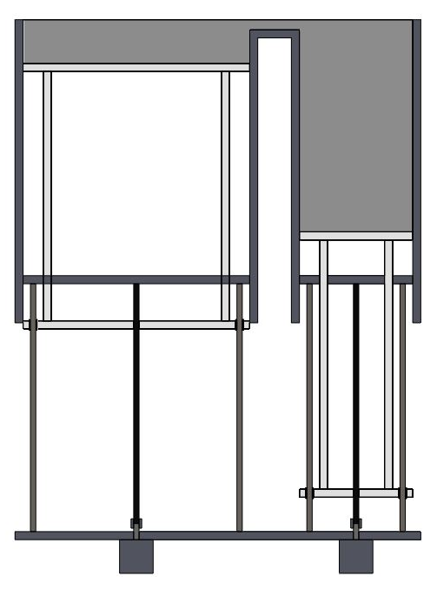
Figure 1

10

10

5

9

9

9

9

8

6
6
7

7

6
6
5

4
2
3
1

Sign
Name: Inventor(s) name
Name of Applicant: National University of Sciences and Technology Sheet 2 of 2

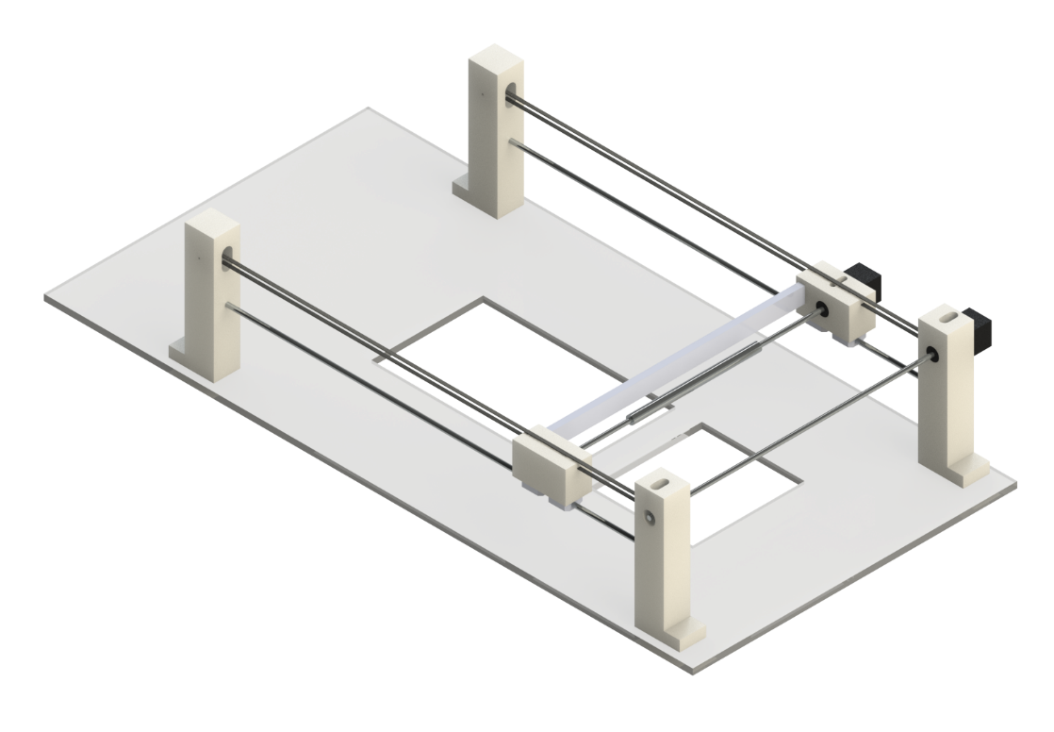
Figure 2
10

9

9

9

9

8

7

6

4

5

4

5

3

3

2

1

Sign
Name: Inventor(s) Name

