Write a proper self-explanatory title of your invention here
ABSTRACT
The abstract shall briefly discuss the technical aspects of the invention so that the reader / examiner gets a general idea about the invention and the technical approach

Main Figure Number: Figure 1

FIELD OF INVENTION:
Please write down the field of invention here
BACKGROUND OF INVENTION (Prior Art )
The background shall be written in the light of the following:
- The closest related prior art may be mentioned.
Prior art means any previously available inventions (patents) or publications or any other material which can refer to an invention which is similar in nature with the current invention.
In-text references / citations of the prior art shall be given here. In case of patents patent number and in case of publication the citation from google scholar can be used.
To carry out a minor prior art search, online databases such as google scholar, patentscope, google patents etc. can be used.
- The technical problem in prior art (which was discussed / mentioned above) addressed
- Technical solution by the present invention
- Advantages presented by the invention

BRIEF DESCRIPTION OF DRAWINGS (Describe here one by one all figures in 2-3 line each.)
- Figure No 1
Figure 1 is a schematic top perspective view of one embodiment of an apparatus for 3D printing in accordance with the invention
Figure No. 2: Figure 2 is a schematic top perspective view of one embodiment of an apparatus for 3D printing in accordance with the invention
DETAILED DESCRIPTION:
- The detailed disclosure of claimed invention will be given here. Please note that this section should directly discuss about the present invention and all the relevant information regarding, the product or process which is essential for its reproducibility shall be mentioned here.
- Describe the technical details: Include a detailed description of the invention's technical features, including any relevant drawings, diagrams, or flowcharts. The drawings will be described in details. All numeral references used in drawings must be explained here.
- Explain the invention's operation: Clearly explain how the invention works, including any novel or non-obvious features that make it unique.
- Provide examples: Give examples of how the invention can be used in practical applications, and describe any potential variations or modifications.
- Discuss the invention's potential market value: Explain the invention's potential for commercialization, including any relevant market data, potential customers, or industry trends.
- Use clear and concise language: Avoid using overly technical or legal jargon that may be difficult for non-experts to understand.

I or We Claim: (Claim should be for a process or product that you want to protect)
1.

Sign
Name: Inventor(s) name
Date: _________________

Name of Applicant: National University of Sciences and Technology Sheet 1 of 2

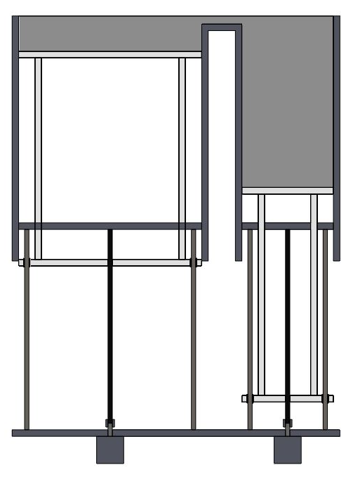
Figure 1

10

10

5

9

9

9

9

8

6
6
7

7

6
6
5

4
2
3
1

Sign
Name: Inventor(s) name

Name of Applicant: National University of Sciences and Technology Sheet 2 of 2

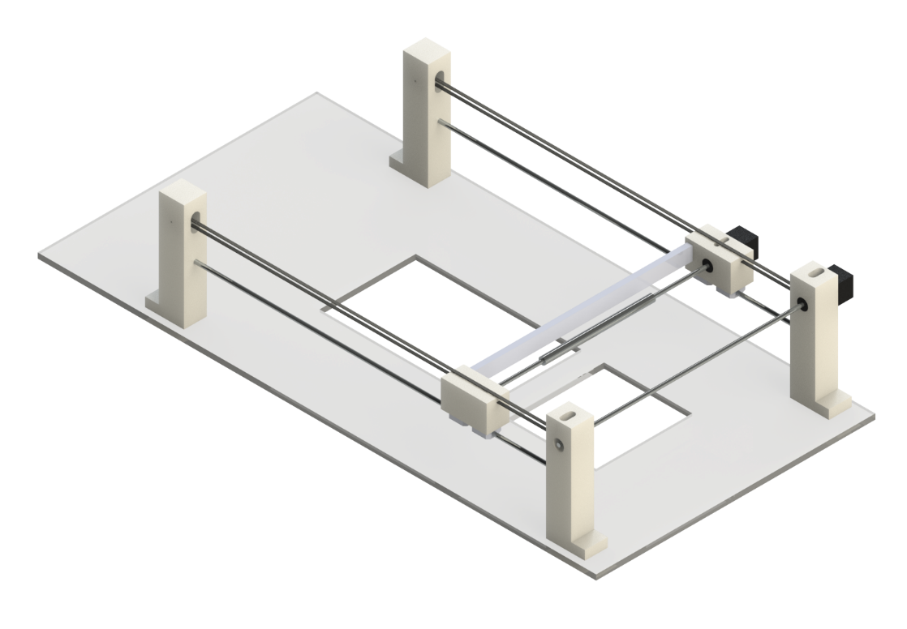
Figure 2
10

9

9

9

9

8

7

6

4

5

4

5

3

3

2

1

Sign
Name: Inventor(s) Name

